Type | Covid-19 | Other pneumonia | total
Train | 1,001 | 984 | 1985
Test | 251 | 246 | 497
Total | 1252 | 1230 | --

Experimental settings and configurations of the models using int this study
Model name | # of batch size | Image size | # of params | Weight size (M)
EfficientNet_B0 |  | 3x224x224
EfficientNet_B3 |  | 3x224x224
MixNet_XL |  | 3x224x224
TResNet_M |  | 3x224x224
TResNet_L |  | 3x224x224
TResNet_XL |  | 3x224x224

Evaluation metrics of the model on the entire dataset
Model name | Precision |  | Recall |  | F1-score |  | Accuracy
Model name | Covid-19 | None-Covid-19 | Covid-19 | None-Covid-19 | Covid-19 | None-Covid-19 | Accuracy
EfficientNet_B0 | 99.20 | 99.11 | 99.12 | 99.19 | 99.16 | 99.15 | 99.15
EfficientNet_B3 | 99.52 | 99.27 | 99.04 | 99.51 | 99.28 | 99.39 | 99.27
MixNet_XL | 99.76 | 99.84 | 99.84 | 99.76 | 99.80 | 99.80 | 99.80
TResNet_M | 99.76 | 99.84 | 99.84 | 99.76 | 99.80 | 99.80 | 99.80
TResNet_L | 99.36 | 99.67 | 99.86 | 99.35 | 99.52 | 99.51 | 99.52
TResNet_XL | 99.84 | 99.92 | 99.92 | 99.84 | 99.88 | 99.88 | 99.88

EfficientNet_B0
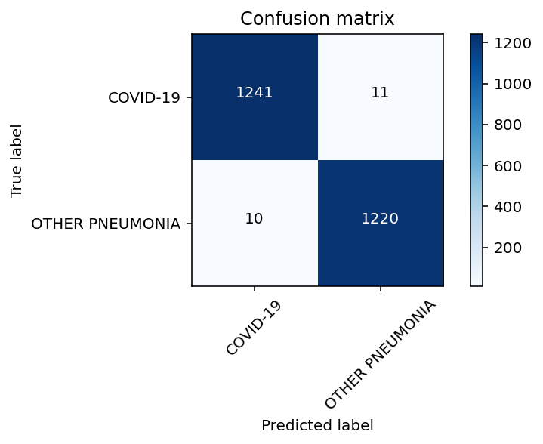

EfficientNet_B3

MixNet_XL

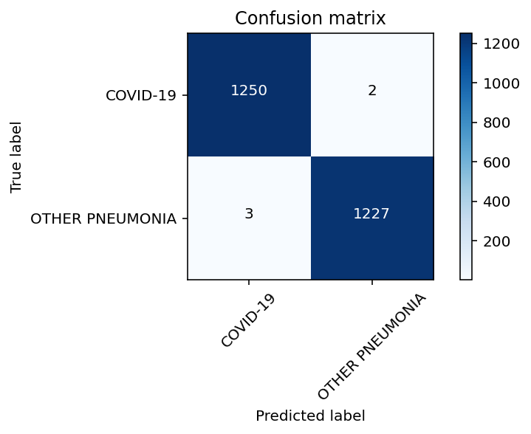

TresNet_M

TresNet_L

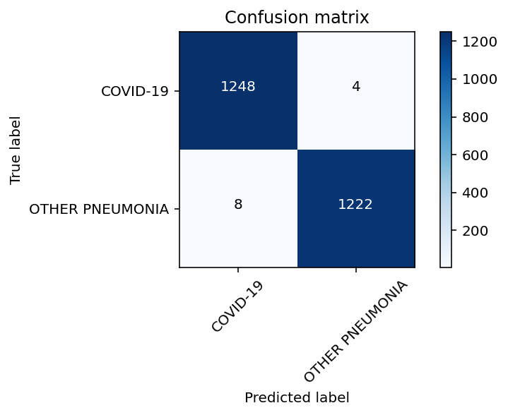

TresNet_XL
